**Functional Document**

|  |  |
| --- | --- |
| **Application** | NGERP - Centra |
| **Service Bundle** | Integrations |
| **Service Request** | Import Payment (HSBC) |

**Description :**

Import Payment (HSBC) is used to import NTA AP using file loader. The payment for NTA AP Invoice is paid using this NTA AP payment .

**Workflow Process :**

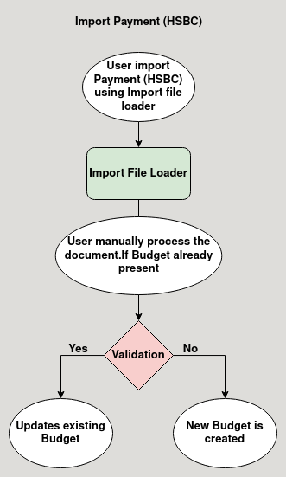

**Business Rules :**

* Import Payment (HSBC) is done in HQ only.
* User import the payment using file loader.
* After clicking the Import Payment manually the applications checks below validatons:
  + If user entered correct region.
  + If the business partner is NTA Vendor.
  + If the Document type is AP Payment.
  + Currency code is VND
  + Payment amount should be greater than 0.
  + The business Partner should have mapped with a valid campaign
  + The business Partner should have Beneficiary Account Numer.
* If the above validations are passed, system allow to import the payment, else throws error in staging screen.